**List of Part Measurements. ‘Hardware’**

**RPi -** Length = 11.3cm , Width = 6.3cm, Height = 5.7cm

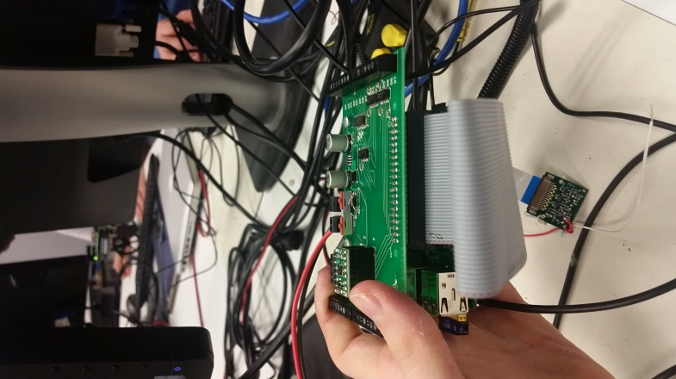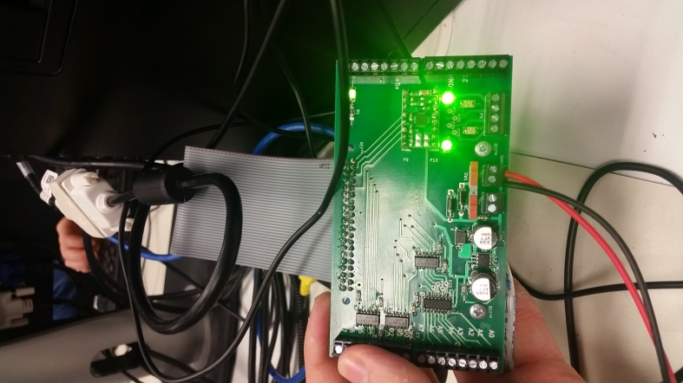

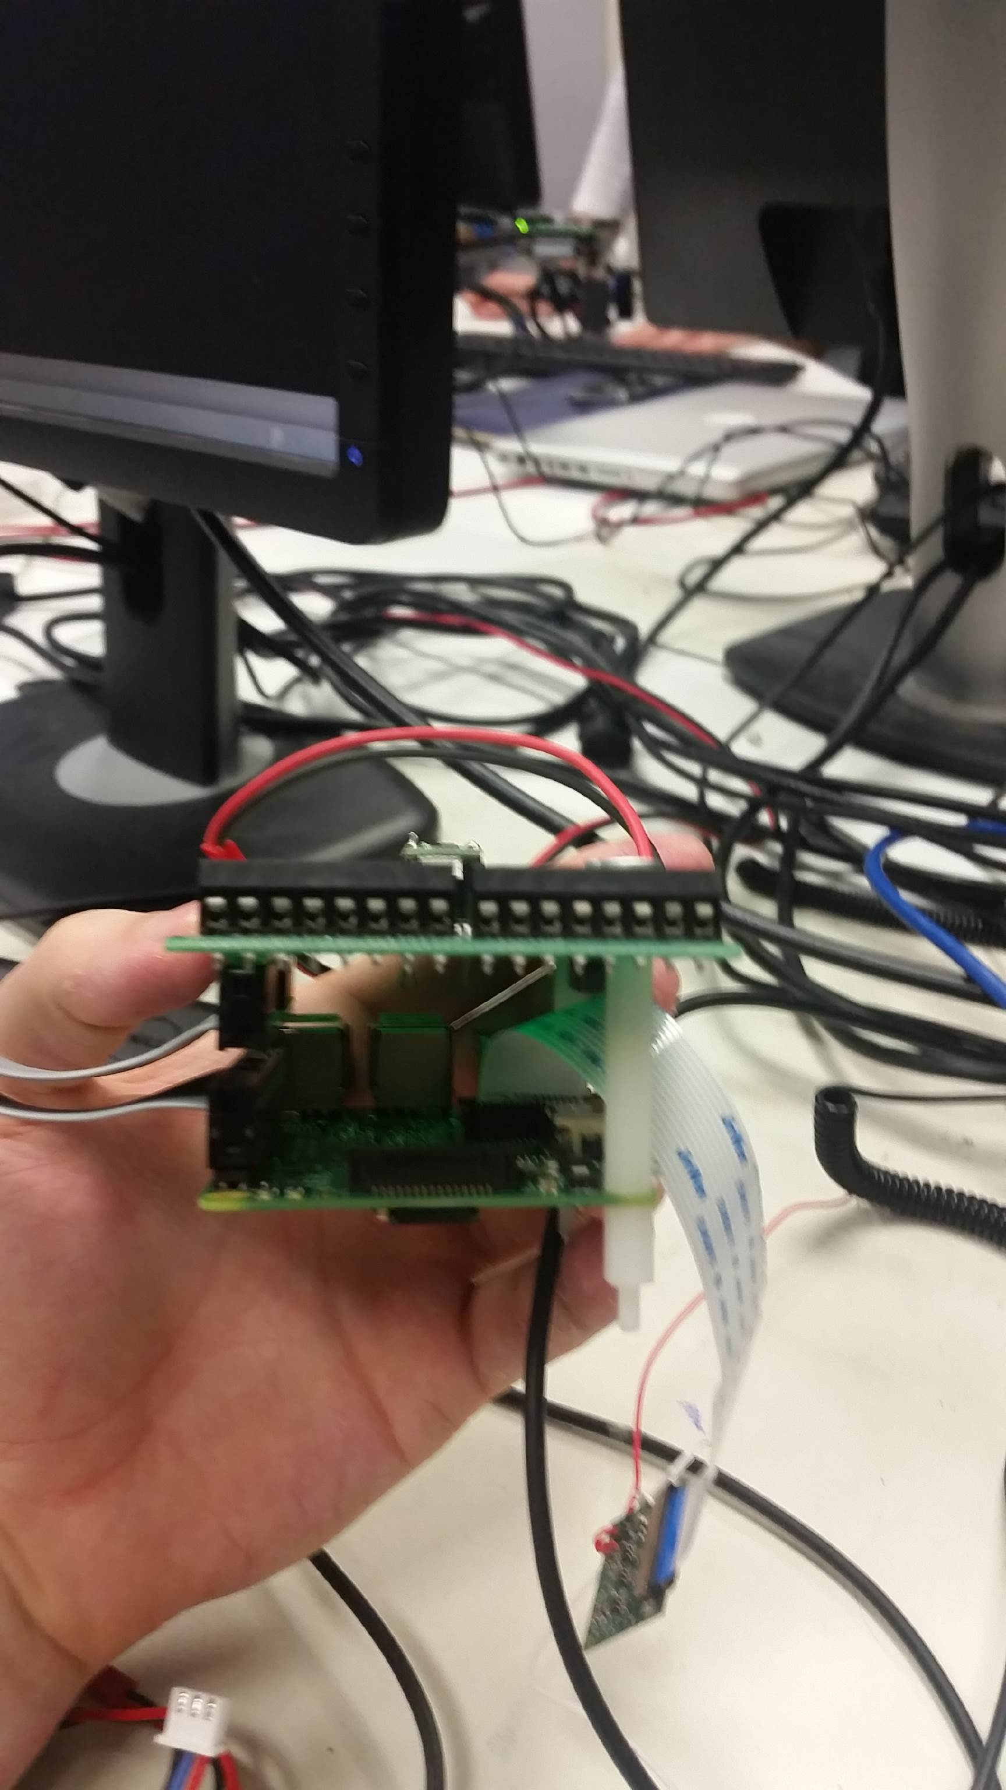

**Big Wheel -** Circumference = 18.85cm , Width =0.7cm, Diameter = 6cm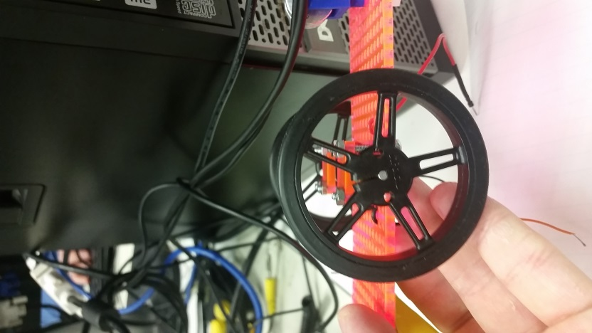

**Small Wheel -** Circumference = 4.4cm , Width = 0.5cm, Diameter = 1.4cm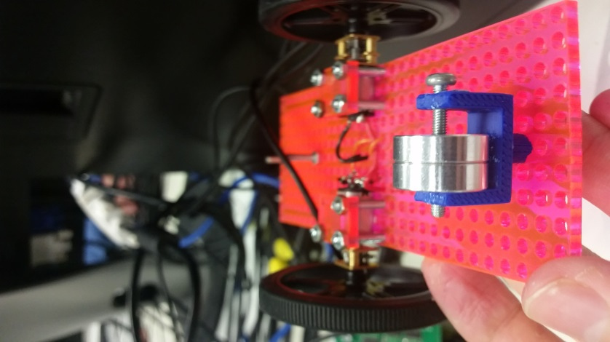

**Camera -**2.5cm x 2.5cm

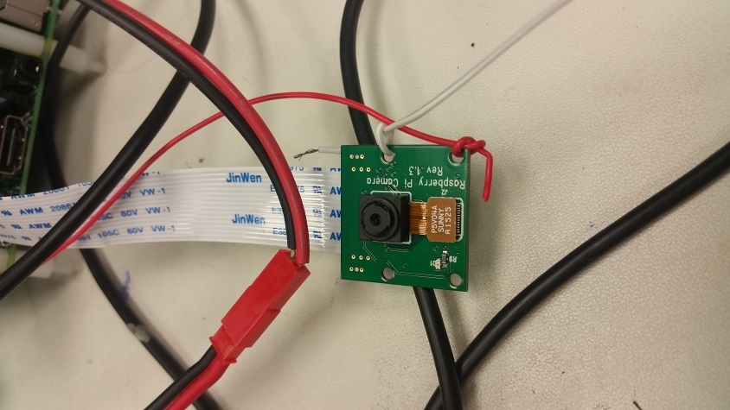

**Battery -** Length = 5.5cm , Width = 3.35cm, Height = 2.8cm

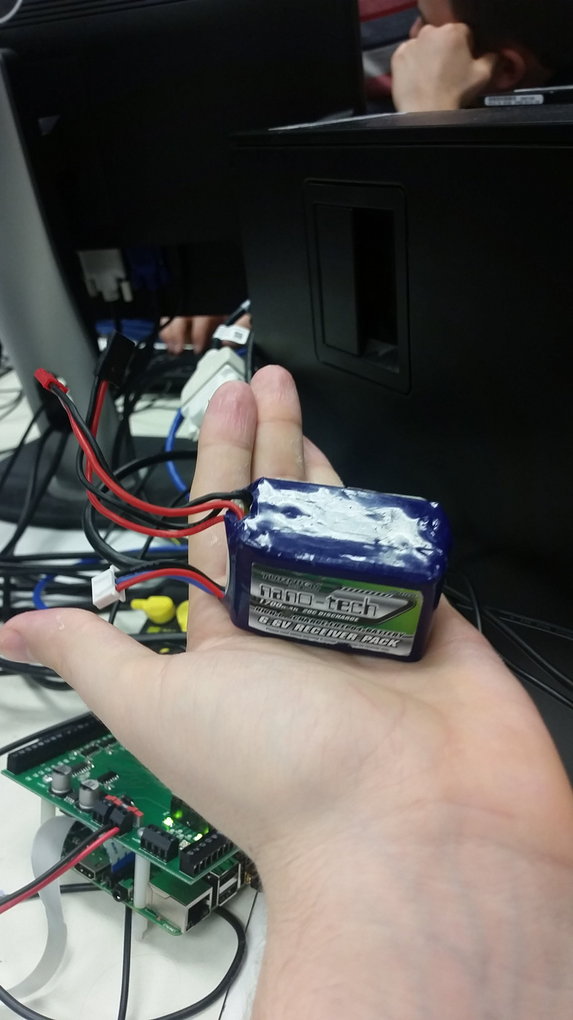

**Sensors -** Length = 1.3cm , Width = 2.8cm, Height = 1.4cm

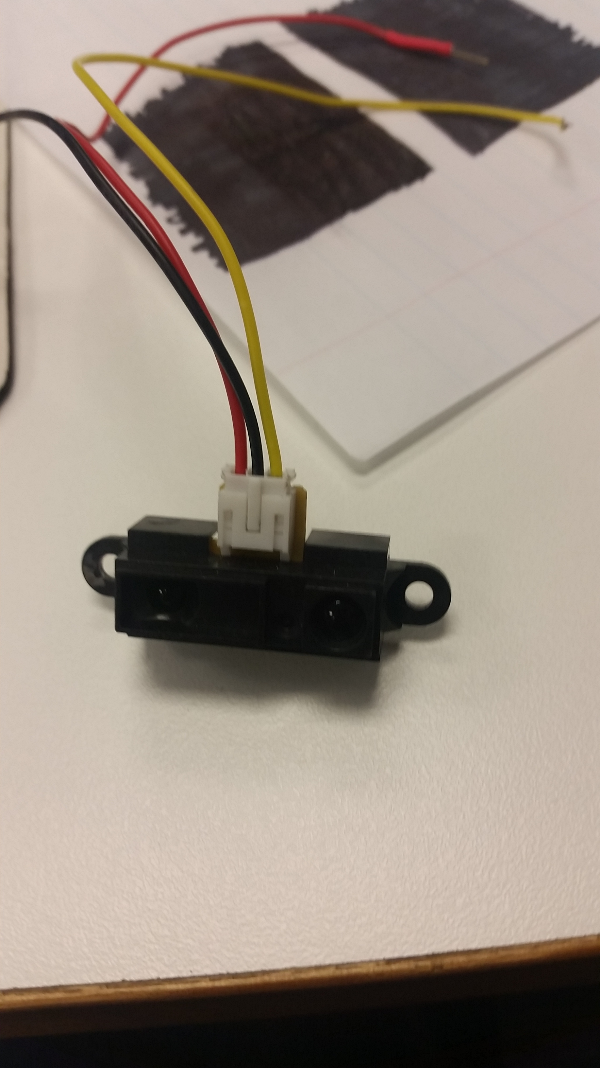

**Board -** Length = 15cm (Will Change) , Width = 5.4cm, Height = 0.3cm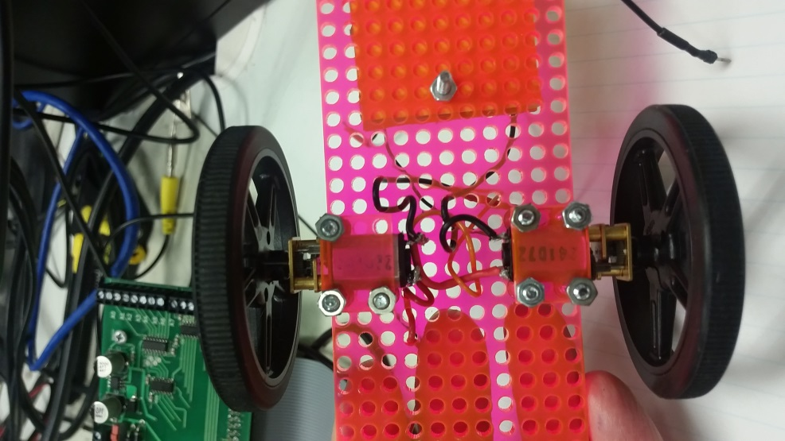

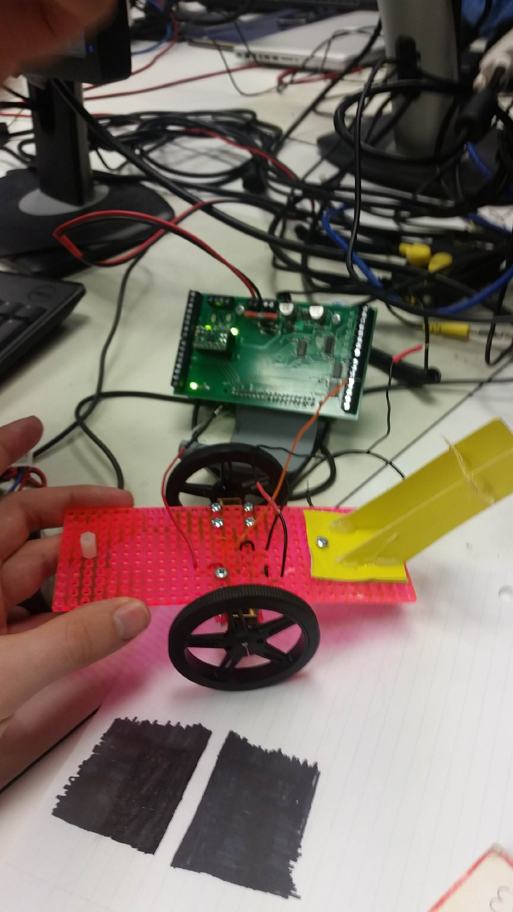

**Motor -** Length = 2.4cm , Width = 2.05cm, Height = 1.7cm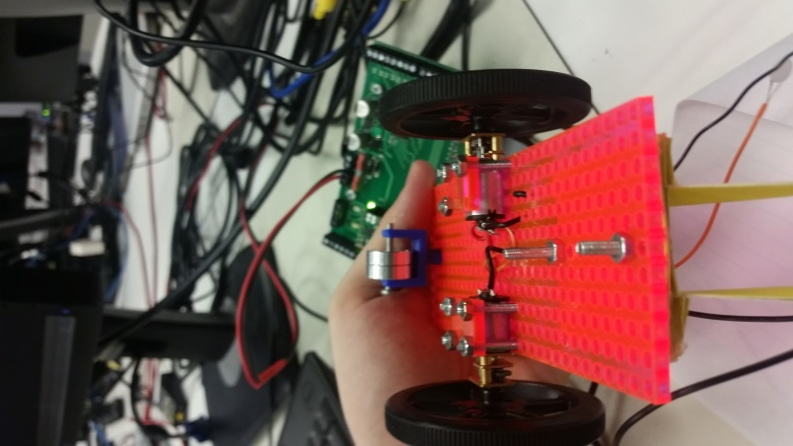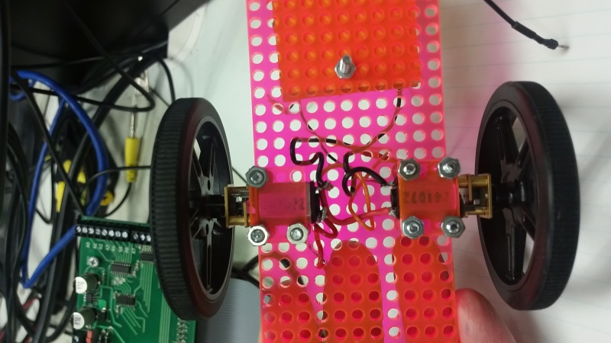

Distance Between Holes = 0.2cm

Diameter of Holes = 0.3cm

Distance Between Holes (width) = 4.6cm

Distance Between Holes (length) = 5.5cm